SPICA-VIS
Optical Design

Doc. No. : SPICA-VIS-0007

Issue: 2

Date: 10/07/2020
Cyril Pannetier, Julien Dejonghe, and Denis Mourard

CHANGE RECORD
ISSUE | DATE | SECTION | COMMENTS
1 | 18/06/2020 | All | Creation
2 | 10/07/2020 | All | Document ready for Design review

Table of Contents
1. Scope 4
2. Implantation in the CHARA Lab 4
2.1 General implantation in the CHARA Lab 4
2.2 SPICA modules on the CHARA Metrology table 5
2.3 SPICA modules on the CHARA Visible Table 6
3. The injection table 8
3.1: General implantation 8
3.2 Detail of the Image & Pupil control 8
3.3 The M3/M4 arrangement for the pupil/image plane active control 9
3.4 Injection device 10
4. The spectrograph 11
4.1 General introduction 11
4.2 Design overview 12
4.3 Explanation of the combiner design 13
4.3.1 Optical Propagation 13
4.3.2 V-groove configuration 14
4.4 Separation of the two channels 16
4.5 Interferometric channel and anamorphosis 17
4.6 Photometric channel 18
4.7 Dispersion 18
4.7.1 Low resolution system R=140 19
4.7.2 Medium resolution R=3600 20
4.7.3 High-resolution R = 10800 20
4.7.4 Mechanical implantation 20
5 Fiber Back Injection 21

Scope
This document presents the optical design of the SPICA-VIS instrument. It details the implantation in the CHARA Focal laboratory, the modules on the injection tables up to the single mode optical fibers, and the visible spectrograph with the science detector.

Implantation in the CHARA Lab
Considering the available place in the focal laboratory and to avoid populating too much the lab in the vicinity of the MIRCx+MYSTIC table, it has been finally decided to install SPICA at the same location as the current VEGA tables. This choice is also guided by the importance of controlling carefully any parasite light in the visible instrument. It permits also important savings with the use of many VEGA pieces.

2.1 General implantation in the CHARA Lab
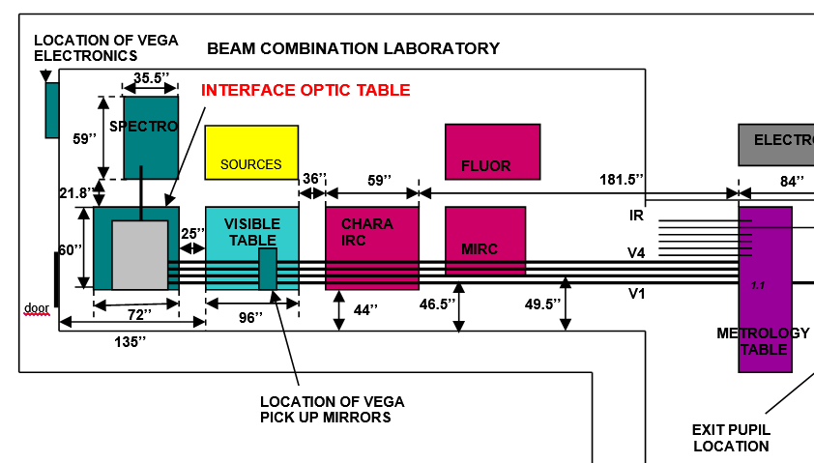
Figure 1: the current VEGA implantation in the Lab (Doc VEG-TRE-002-V7)
Figure 1 presents the implantation of the VEGA modules. By comparison to VEGA, the following changes will be implemented for SPICA:
- Addition of the new STS-VIS dichroics on the metrology table to feed SPICA with the 6 beams coming from the STS.
- Addition of the new Visible LDC on the metrology table.
- The new SPICA periscope will accommodate the 6 CHARA beams. Its location will be at the north side of the CHARA Visible Table.
- The VEGA Interface Optic Table will become the SPICA Injection Table. Its height will be adjusted.
- The VEGA Spectrograph Table will become the SPICA Spectrograph Table. The link between the two SPICA tables will be done by the optical fibers.
- A new cabinet will be installed in the South Corridor for the SPICA electronics.

2.2 SPICA modules on the CHARA Metrology table
The metrology table will host the 6 new adjustable Visible LDCs and the new movable STS-VIS, represented by the devices on the blue beams in Figure 2. The module in the red beams corresponds to the STS-IR switchable systems. Figure 3 presents the current implantation on the metrology table.
Focal Lab
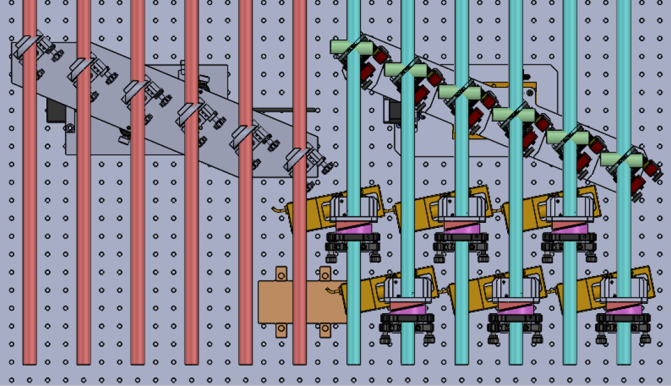
STS
Figure 2: STS-IR, STS-VIS and VIS-LDC on the metrology table
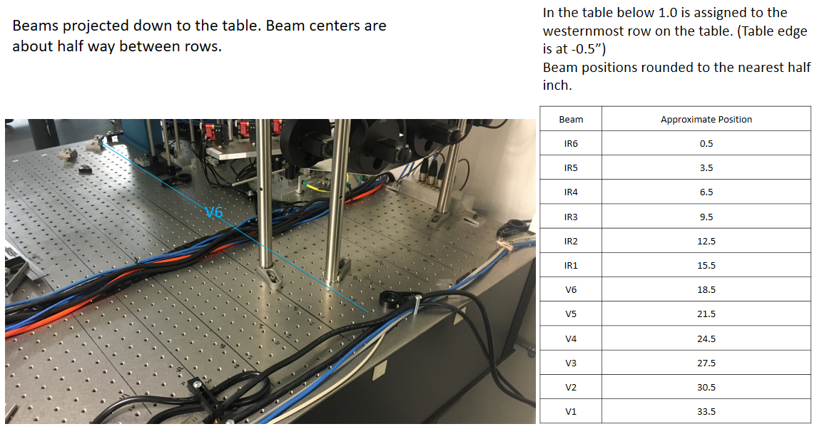
Figure 3: Current implantation on the metrology table with the free space for the VIS-LDC and STS-VIS modules.

2.3 SPICA modules on the CHARA Visible Table
After the metrology tables, the visible beams cross the MIRCx and the IR tables and arrive on the CHARA visible table. To combine the operation of SPICA together with the need of using the CHARA reference source, the principle of a switchable periscope is used as was done for VEGA.
To accommodate the 6 beams for SPICA in the periscope, it has been decided to rearrange the CHARA Visible Table as presented in Figure 4 below:

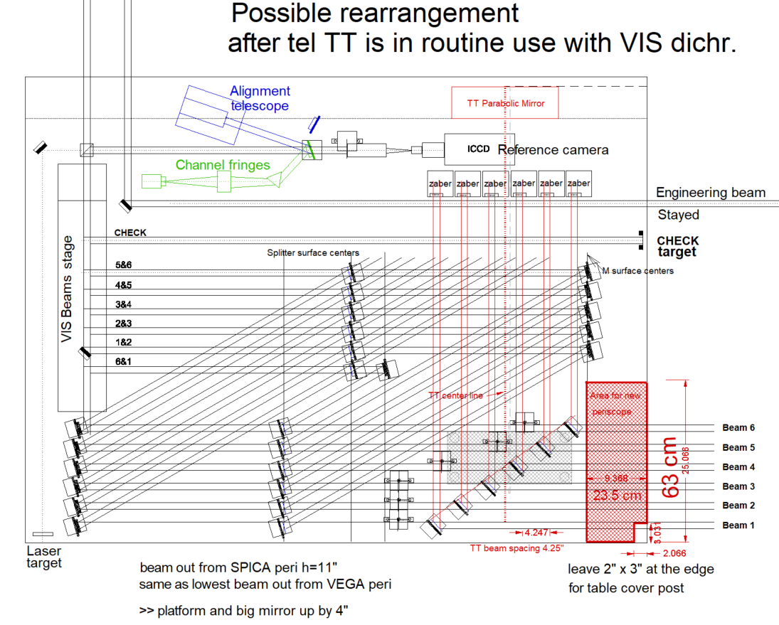
Figure 4: Rearrangement of the CHARA Visible Table and free space available for the SPICA periscope

The periscope is made of 2 mirrors (M1&M2) on each of the six beams. The six M1 mirrors are mounted on a switchable system, each M1 mirror being mounted independently on a static device permitting a perfectly repeatable position in SPICA mode. The six M2 mirrors are equipped with motorized tip/tilt functions. These 6 M2 mirrors and the six motorized M3 mirrors located in an image plane on the injection table, allow a complete and active alignment of the CHARA and SPICA beams.
After the M2, the beams are transferred horizontally to the injection table. On each beam a module for the correction of the atmospheric refraction (ADC prisms 1&2) is installed just after the M2 mirror and on the general structure of the periscope, as presented in Figure 5.
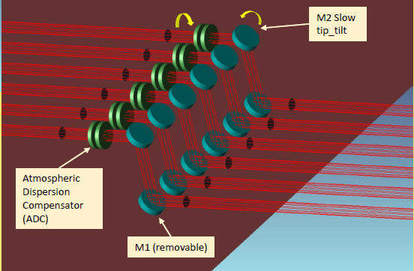
Figure 5: optical design of the Periscope + ADCs
The specifications of the ADC device are presented in the SPICA-Refraction and in the General Requirement documents. It is composed of two wedged substrates (WSB-50C08-20-1 WSSQ-50C08-20-1). One is moving relatively to the others depending on the level of correction that is needed (as a function of azimuth and altitude) and both prisms are, in addition, moving together to follow the field rotation of the CHARA telescopes. It should be noted that the ADC introduces a deviation of the beam (in image and pupil) that is compensated by the combination of M2&M3 mirrors. Calculation shows that the ADC must be adjusted every 10 minutes only.

The injection table

3.1: General implantation
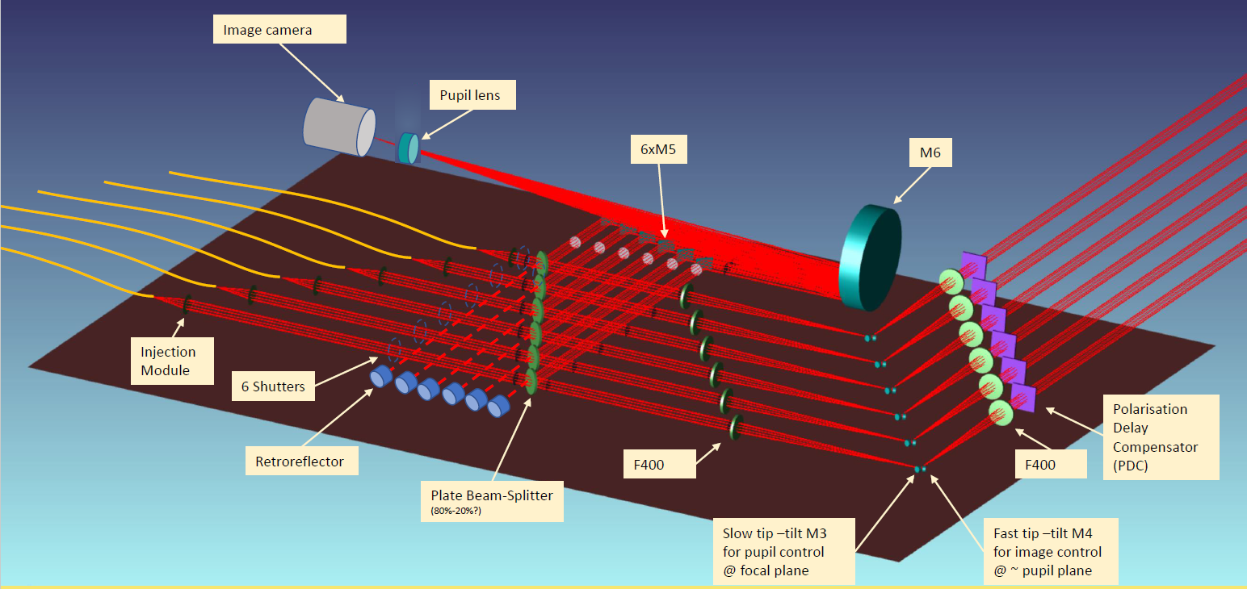
Figure 6: General implantation of the SPICA injection table
After the periscope and the ADC, the beams arrive on the SPICA injection table. Each beam will go successively through:
- the PDC: Polarisation Delay Compensator
- L1: a F400 achromatic doublet forming the image plane on M3 (AC508-400-B-ML)
- M3: 1/2'' flat mirror for slow tip/tilt motion in image plane for the control of the pupil plane.
- M4: 1.2'' flat mirror for fine image stabilization located in the pupil plane and mounted on the PI fast tip/tilt device
- L2: a F400 achromatic doublet collimating the beams
- BS: a R/T=80/20 beamsplitter sending 20% of the visible light for the image and pupil control.
- Injection module

3.2 Detail of the Image & Pupil control
The image&pupil control uses the ANDOR Ixon897 detector on which the 6 image planes are formed to close the loop of the fast tip/tilt motions. A movable pupil lens permits to image the 6 pupil planes to control the M3 setting. The M2 is used to desaturate the fast tip-tilt.
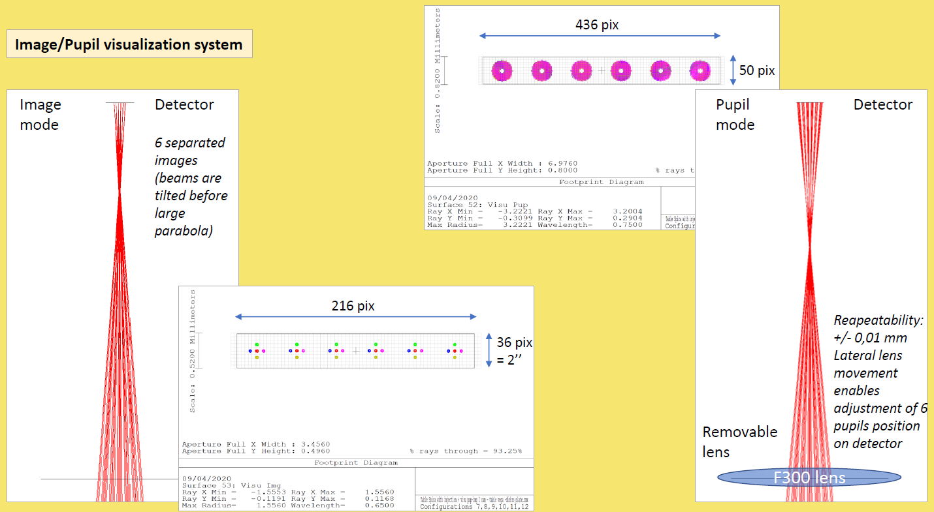
Figure 7: the Image & Pupil control

3.3 The M3/M4 arrangement for the pupil/image plane active control
Placed in a focal plane, a slow tip/tilt mirror M3 stabilizes the pupil. Near the approximate pupil plane, the fast tip/tilt mirror M4 stabilizes the injection into the fibers. To avoid generating fast piston errors, the beam must always be precisely centered on the fast tip-tilt rotation point. Considering tip/tilt correction of +-0.3'' (sky) it corresponds to 0.0001rad. A centering error of 0.1mm generates a fast piston of 10nm. Considering the diameter of the pupil on the M4 (0.37mm) it means that we need to center the pupil with an accuracy of less than 27% to not introduce fast piston noise. The setup of M3/M4 is presented in Figure 4. Note that for the same reason, all other motorized mirrors must rotate around their center, with the beam correctly centered on it, to avoid producing slow piston errors.
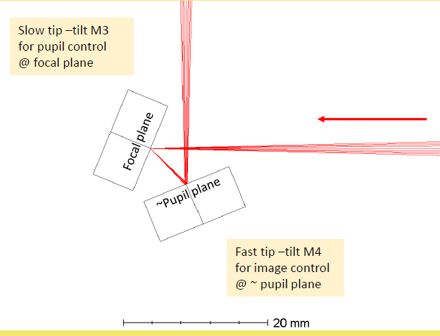
Figure 8: configuration of the M3/M4 mirrors for the pupil and image plane stabilization.

3.4 Injection device
It is not possible to inject all the energy contained by the PSF into a fiber. Meanwhile, the injection device can be optimized to reach a maximum efficiency. Zemax simulations show that the theoretical efficiency with a perfect optic is 83%, with no central obscuration. Taking central obscuration into account leads down to 72%. Still in theory, a perfectly fitted and aligned off-axis parabola could reach this level with no chromatism, but we considered that, in practical, surface aberrations and misalignment would quickly degrade the performance. We studied a lens system made with an achromatic doublet and a plano-convex, from Thorlabs. This system reaches 71% efficiency. First lab tests show that the setup reasonably fits the theory. The two optics are maintained at their adequate position by construction, while focus is obtained thanks to fine adjustment of the distance between the second lens and the fiber. All centrings are nominal and not adjustable, as the tolerance for this aspect is not so tight. We obtain a precise and fast adaptive centring of the bright speckle into the fiber thanks to the fast tip-tilt mirror. Finally, the entire injection device longitudinal position is adjusted with a translation stage to control the OPD.
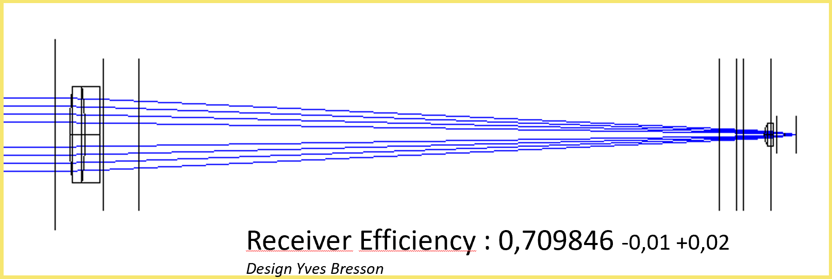

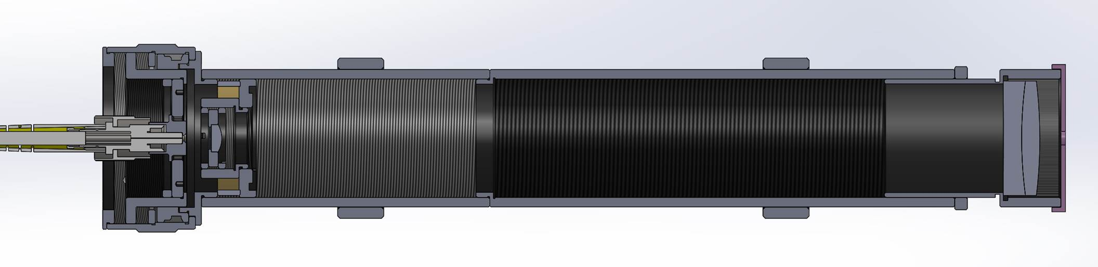
Figure 9: optical and mechanical study of the injection module

The spectrograph

General introduction
The SPICA-VIS spectrograph uses the principle of dispersed fringes in the image plane, after a linear and non-redundant arrangement of the pupils at the output of the V-Groove. The entrance plane of the spectrograph is defined by the V-Groove assembling the 6 main single mode fibers (PM630-HP) in a non-redundant linear configuration. The V-Groove is made as an assembly of 4 8-position V-groove with a pitch of 250µm and defining 35 positions with 3 forbidden ones (9, 18, and 27). The 6 main fibers are installed at the positions: 1, 7, 11, 19, 33, and 35, as presented in Figure 9. This configuration defines the set of output baselines (3B – 2B – 4B – 7B – B). Additional fibers are installed to illuminate the spectrograph with spectral calibration lamps. The V-groove is manufactured by the Leukos company, according to the requirements described in Document SpecsCombinerV2.docx.
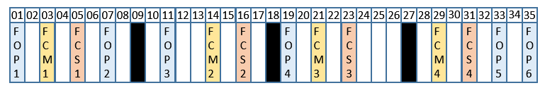
Figure 10: SPICA-VGroove: FOP1...6 are the main fibers, FCM1...4 are additional multimode fibers, FCS1...4 are additional single mode fibers.
One important feature of the SPICA-VIS spectrograph is that it permits to accommodate the anamorphic interferometric beam (for the correct spatial and spectral sampling) together with dispersed photometric channels imaged on the same detector but in pupil plane.
Following the science requirements, the main specifications of the spectrograph are presented in Table 1.
Table 1: General specifications of the SPICA-VIS spectrograph
Requirement | Values
Number of telescopes | 6, linear non redundant configuration
Spectral range | 600 nm – 900nm (guaranty 650 – 850nm)
Spectral resolution | 140, 3000, 10000
Photometry needed | Photometric channels are needed to correctly process the visibilities.
Fringe measurement | We want to measure the complex visibilities of the 15 interferometric patterns.

From the general system analysis, we deduce some numerical specifications concerning the sampling and the dimension of the V-Groove:
Table 2: Sampling characteristics
Parameter | Default choice
Microlens diameter D | 218µm
V-groove separation distance d | 250µm
Unitary base B | 2*d = 500µm
Fringe sampling FS | 2,94 pixels/shortest fringe @650nm
Spectral sampling SS | 2 pixels per FWHM @650nm
Spatial sampling of photometry | < 2 pixels/FWHM @650nm
Pupil configuration | 3B – 2B – 4B – 7B – B
Pixel size | 13µm
Number of pixels | 1024x1024
Calibration fibers | Presence of calibration fibers on the V-groove
Fiber Back Injection | Injection in fibers for co-alignement of SPICA

Design overview
The layout presented here corresponds to the optical design of the R=140 low resolution mode. It has been developed to be consistent with the other high resolution modes that make use of a blazed reflective diffraction grating. When a high resolution mode is operating, the mirror is replaced by the corresponding diffraction grating (by turning the tower on which the two gratings and the mirror are cleverly positioned) and the prism is removed (manually or automatically).

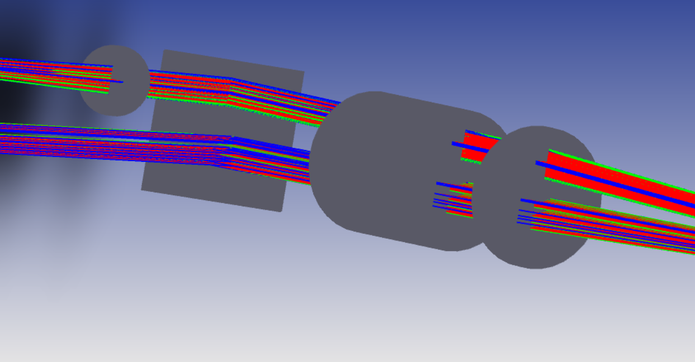
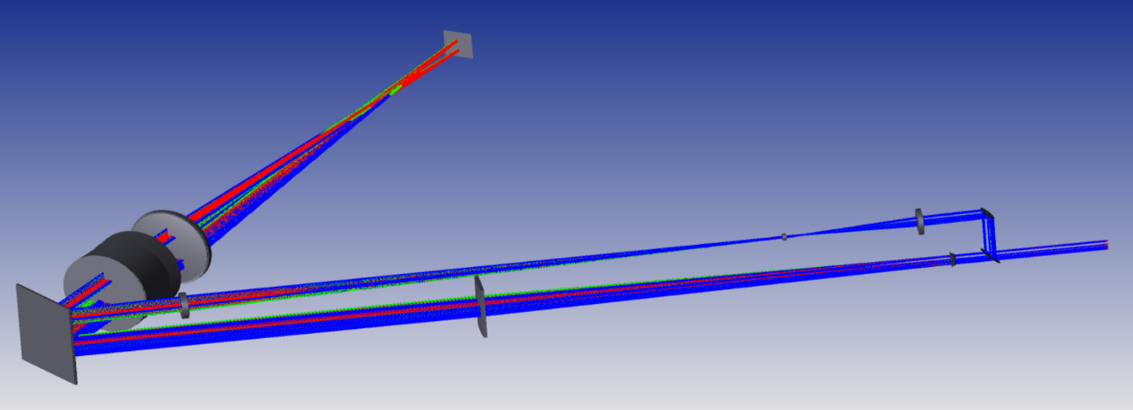
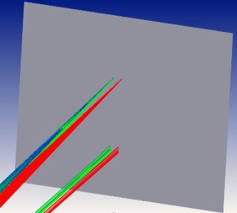
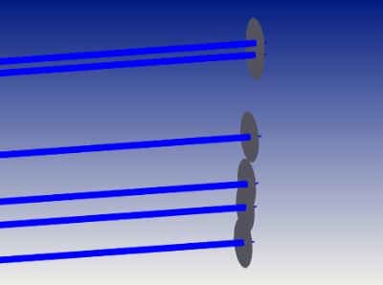
L1
L2
L3
L2 cylindrical
L1 cylindrical
Prism
Imaging lens L4
Detector
Image of the µlenses
Fringes in focal plane
Beam splitter
10/90
Figure 11: The optical layout of the spectrograph SPICA-VIS is presented. At the top, we see all the entire design, with the reimaging photometric channel to the top and the anamorphosing intereferometric path to the bottom. Both channel is reflected on the mirror and passes through the non-deviating prism and imaging lens CAO. We see on figure (b) the positions of the two channels: the fringes are made in image plane while the six beams of the photometric channels are side-by-side in pupil plane in the spatial direction.
Lentille L3, miroir de renvoi, prisme et lentille imageante L4

Explanation of the combiner design

Optical Propagation
At the output of each optic fiber is placed a microlens that collimates the beam. These microlenses have a diameter of 218µm in order to respect the crosstalk resilient requirement.
Then, the beams are split in two channels with a ratio that equalizes the energy repartition on the pixels of the detector (the sampling are not the same). Those channels are:
- The interferometric channel ($∼90\%$ of the energy): the goal of this channel is to get the complex spectral visibilities of the 15 bases by dispersing the interferometric pattern on the detector.
The cylindrical lenses FCL and SCL perform an anamorphosis (factor 57) by stretching the beam in the spectral direction so that both the fringes sampling (3 pixels for the shortest fringe) and the spectral sampling (2 pixels per spectral channel) are correct in the focal plane of the imaging lens. A mirror (LDM) deviates the beam to the dispersing non-deviating prism (LFP and LSP). The camera lens L4 (CAO) finally focalises all the light on the detector SDT. We get the fringes pattern in the X direction and the dispersion in the Y direction.
- The photometric channel ($∼10\%$ of the energy): the goal of this channel is to calibrate the flux of each beam to correctly process the complex interferometric visibilities. The lenses FLS and SLS reimage the microlenses with a magnification of 1:10 at a position close to the SLS. This image is then transported by a third achromatic lens TLS that collimates the diffracted beam. Finally, after its dispersion, the camera lens CAO reimages it with a 1:1 magnification on the detector.
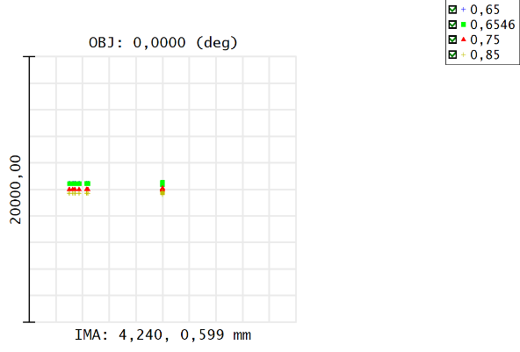
Finally, we get on the camera the anamorphosed fringe pattern of the interferometric channel alongside the six photometric dispersed images of the microlenses.
384pix
100pix
Interféro
Photo
Figure 12: Arrangement of the phtoometric and intereeferometric channels on the detector. The blue squares show the physical image pattern. 99% of the intereferometric channel energy is contained whithin 400 pixels, resulting in a pollution of less than 0,5% of the photometric channel energy.

On the detector, the different channels will be sampled as follow:
Channel | Sampling | Number of pixels illuminated by the channel
Photometry | 2pix/beam | 100
Interferometry | 3pix/shortest fringe | 400
Total |  | 500
Table 3: sampling on the detector at $λ=750nm$
Even though we have a 1024x1024 pixels camera, we put the photometric channels as close as possible from the interferometric channel in order to maximize the readout rate. According to calculations, in a 512 (spatial) x 1024(spectral) configuration, the energy coming from the interferometric channel won’t be higher than 0,5% of the closest photometric channel. For this configuration (500x1024), we can reach a readout rate of 50Hz with the Ixon 888, which corresponds to the coherencing mode requirement.

V-groove configuration

Frequencies coding
As the V-groove allows positions at integers numbers of 250µm, the closest fibers are separated with B=500µm. This allows the collimation with microlenses of reasonable radius of curvature. Moreover, the microlenses diameter is limited by D<B/2 to avoid the power spectrum of each frequency overlapping each other’s (non-crosstalk criteria). As we are not limited by the detector size, we chose to code the different spatial frequencies with a non-redundant configuration, but of course the most compact one to avoid too much spreading. Finally, our configuration is: 3B – 2B – 4B – 7B – B.

For the reimaging beam, we chose AC508-500-B - f = 500.0 mm, Ø2" Achromatic Doublet, ARC: 650 - 1050 nm that samples the longest baseline (hence the shortest fringe period) on 2,94 pixels at 0,65µm (and 3,85 pixels at 0,85µm).
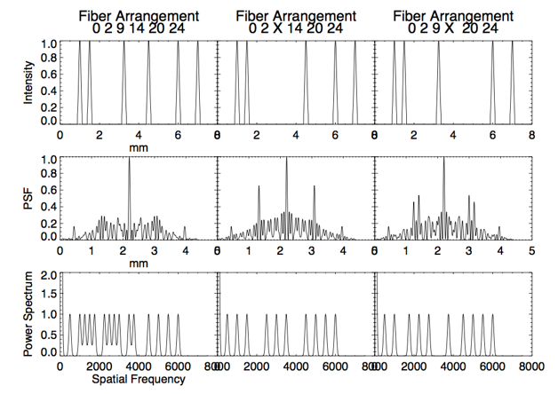
The diameter of the microlens is 218µm. This avoids any crosstalk (at least in theory) within the spectral channel. Finally, $B_{unit}=2,3Φ_{µlens}$.
Figure 12: MIRCx’s fiber arrangement possibilities that illustrate the concept of crosstalk and redundancy. The left configuration has crosstalk but is non-redundant (because all peaks are distinguishable) while the two others don’t have crosstalk.

Microlens array
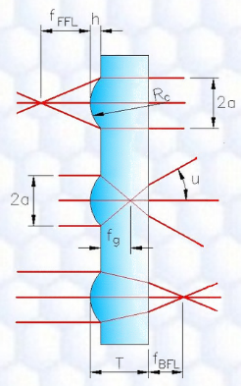
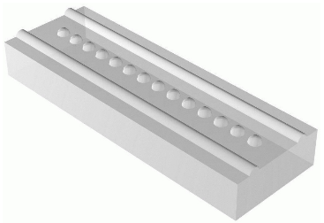
Figure 13: Representation and technical drawing of a microlens array from AMUS
For our mircolens array, we choose the company AMUS because they have a capacity of making microlens array of a large range of caracteristics. Our microlens will have the following caracteristics (lengths in µm):
Material | NA | Radius 1 | Radius 2 | EFL | f_{BFL} | Diameter | Width | Pitch
BK7 | 0,12 | 462 | Infinity | 900 | 759 | 218 | 200 | 500

Spectral calibration
Additional fibers are mounted on the V-groove VGR to perform the spectral calibrations. The sources will be selected with the requirement of having at least three identified lines for the smallest spectral band (highest spectral resolution).
We decided to use spectral calibration sources from www.oceaninsight.com. These sources will feed the spectrograph thanks 2 multimode fibers inserted in the V Groove. We proposed to use two spectral calibration sources: Neon and Mercury/Argon (https://www.oceaninsight.com/products/light-sources/calibration-sources/wavelength-calibration-sources/). In the following figure, we plot the strong spectral lines (between 650nm and 850nm) of both sources.

Figure 14: Neon/Argon spectral lines
The specification of the SCU is to have at least 3 spectral lines per spectral band in the HIGH resolution mode (ie 25μm). Using both Neon and Mercury/Argon sources allows to fulfill this specification except for 3 spectral bands: [675,700], [775,800] and [825,850]. For these 3 bands, we will have 2 spectral lines only.

Separation of the two channels
To equalize the contrast between the two channel as good as possible, we choose to split the beams between a 10% and a 90% parts. We found a beam splitter at Chroma that give a split ratio close to 10/90 on the wavelength range 600 – 900nm. As the beams all pass through the same beam splitter, the possible phaseshift introduced at the reflection or transmission is the same for all beams so the OPD is not impacted. However, some ghosts can be experienced.

Interferometric channel and anamorphosis
$$3λ_{0,75}/D$$
$$λ_{min}/B_{max}$$
$$λ_{min}/B_{min}$$
Figure 15: Airy pattern for one wavelength in the focal plane of the imaging lens

The anamorphosis concerns only the interferometric channel. The different sampling needed in spectral and spatial directions imposes that the image is stretched in the spatial direction compared to the spectral direction, giving the oval shape on Figure 4.
The anamorphosis factor AF is the diameter ratio between the two different axes of the image pattern on the detector, or of the collimated beam $Φ_{x}$ and $Φ_{λ}$ before focalisation.
This ratio is performed thanks to a pair of cylindrical lenses that reshape the collimated beam in the spectral direction, stretching. The two cylindrical lenses are:
- A 9,69mm focal one: LJ1822L1-B - f = 9.69 mm, H = 10.00 mm, L = 12.0 mm, N-BK7 Plano-Convex Cylindrical Lens, Antireflection Coating: 650-1050 nm
- A 400mm focal one: consultation with some companies are underway to find a plano-convex lens larger than 40mm in the refracting direction. Fichou company has got a plano-convex of these dimensions, the coated is custom.
Whereas the anamorphic ratio should be 58, we see that it is actually 41. This is explained by the diffraction that helps the beam to spread in the spectral direction.
Finally, we get the image pattern in Figure 16.
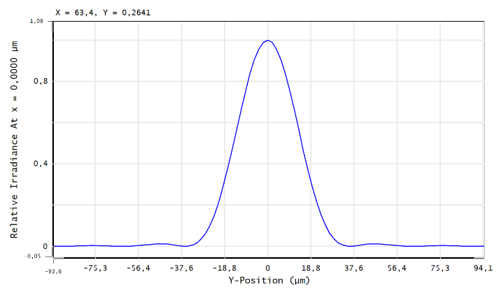
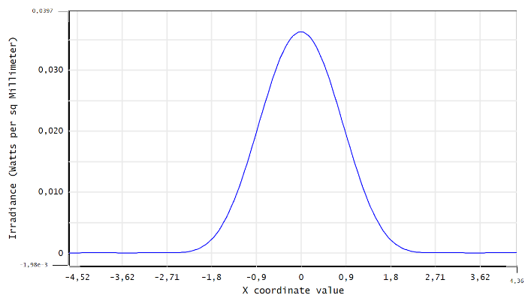
Figure 16: Image patterns of the interferometric channel in the spatial (left) and spectral (right) directions.

Photometric channel
To avoid the use of a faceted mirror that is hard to manufacture for the dimensions involved, we choose to image the V-groove on the detector. This is achieved using three achromatic lenses from Thorlabs. The two first lenses are the 100mm-focal length AC254-100-B and the 15mm-focal length AC064-015-B that image the V-groove with the expected resolution. Then, the 500mm-focal length AC254-500-B collimates the diffracted beam before the dispersing section. The common 2 inches imaging achromatic lens finally reimages the V-groove on the detector.
This design allows us to sample each full-width-at-half-maximum of the gaussian image on less than two pixels of the detector.
Moreover, all beams are aligned on 100 pixels and the center of the two closest beams are separated with 6 pixels.
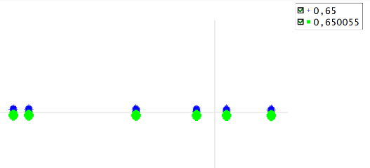
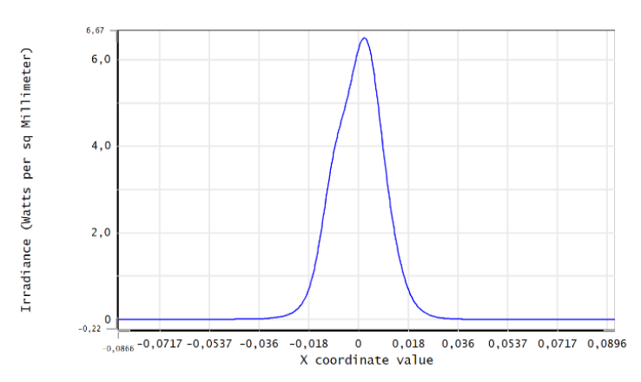
Figure 18: Spot Diagram of the photometric channel in high resolution.
1,3mm
Figure 17: Image cross section of the photometric channel. The assymetry is due to some numerical sampling troubles with the Physical Propagation tools of Zemax.

Dispersion
The dispersion system needs to reach a large range of spectral resolutions:
- R = 140: A mirror reflects all the flux toward a non-deviating prism that disperses the beam before the imaging lens.
- R = 3000: A 300 grooves/mm ruled diffraction grating. The dimension needs to be adjust to 50x50mm.
- R = 10000: A 900 grooves/mm ruled diffraction grating. The dimension needs to be adjust to 50x50mm.
As we didn’t find suitable gratings in classical catalogs, we are approaching Jobin-Yvon and Holographix.
The position of the camera will be the result of the best compromise between the high and medium spectral resolution as long as the blazed angles.
The three reflecting elements will be settled on a rotating tower for automatically shift the spectral mode and the measured spectral band.

Low resolution system R=140
As the dispersion is done thanks to a non-deviating prism, there is no constraint on the angle of the mirror. It is equal to half the optimal angle $θ_{0}$ of the camera. The non-deviating prism is made of two wedge glasses.
On the detector, all the spectral band from 0,6 to 0,9µm is spread onto 90 pixels.
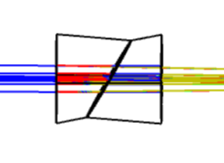
Unless we find a catalog direct-vision prism (not yet found despite researches), the custom direct-vision prism is made of N-LAK21 and SF2 with an angle of 30° between each.
Figure 19: Direct-Vision Prism made of N-LAK21 and SF2 for reaching R=140

As we didn’t find any direct-vision dispersive commercial component, we imagined a solution using two equilateral prisms made of F2 (PS854) that gives the expected spectral resolution. See below.
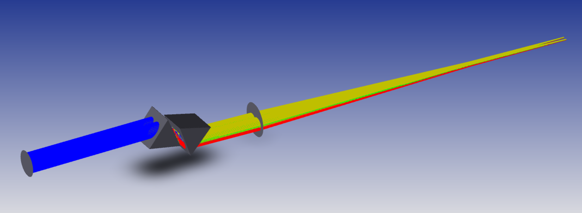
Figure 20: Low resolution dispersion solution using two commercial F2 equilateral prisms from the Thorlabs catalog.

Medium resolution R=3600
The medium resolution is reached with the ~300 grooves blazed (optimized at 800nm) diffraction grating from HORIBA. Needs to be confirmed.
Dimension: 50x50mm
Bandwidth: 70nm @650nm

High-resolution R = 10800
The high-resolution is reached with the ~900 grooves blazed (optimized at 800nm) diffraction grating from HORIBA. Needs to be confirmed.
Dimension: 50x50mm.
Bandwidth: 25nm @650nm

Mechanical implantation

Figure 21: Spectrometer in medium resolution configuration. The wheel and its on-board components are at scale. The imaging and detector sizes are not (but their positions are)
R10000
R140
R3000
detector
Imaging lens
~400mm
Rotating selecting wheel
Beams

R10000
R140
R3000
detector
Imaging lens
~400mm
Figure 22: Spectrometer in low resolution configuration. The wheel and its on-board components are at scale. The imaging and detector sizes are not (but their positions are)
Rotating selecting wheel
Beams

Fiber Back Injection
To align the instrument, we need to inject light into the six fibers as explained in the document SPICA-VIS-coalignementprocedure.docx. The mechanism has not been studied yet. However, here is what we are thinking about.
Collimated anamorphosed laser source
Movable mirror
Back-propagating beam shape
Back-propagating beams
Toward photometric chanel
Toward interferometric chanel
Figure 23: Optical concept of the back fiber injection system
100mm

The longest baseline is $B_{max}=8,5mm$, which gives a fringe period equal to $Φ_{min}=λF/B_{max} =38,4µm$ at $λ=0,65µm$. Remind: the pixel size is p=13µm.
To avoid crosstalk within a spectral channel $δλ$, we need that the maximum frequency of the 16B pair $f_{16B}=\left(16B+D\right)/λ_{min}$ stays below the minimal frequency of the 17B pair $f_{17B}=\left(17B-D\right)/\left(λ_{min}+δλ\right)$. This gives D<221µm.
Given the resolution criteria $SS=2$ (spectral sampling: 2pix/$δλ$) and $FS=3$ (fringe sampling: 3pix/shortest fringe): $\frac{λf}{Φ_{λ}}=SS$and $\frac{λf}{B_{max}}=FS$. Which gives $AF=\frac{Φ_{λ}}{Φ_{x}}=\frac{FS}{SS}*\frac{B_{max}}{Φ_{x}}=57$.

