SPICA-VIS
Mechanical Design

Doc. No. : SPICA-VIS-0008

Issue: 2

Date: 10/07/2020
Christophe Bailet and Philippe Berio

CHANGE RECORD
ISSUE | DATE | SECTION | COMMENTS
1 | 16/06/2020 | All | Creation
2 | 10/07/2020 | All | Ready for Design Review

Table of Contents
1. Scope 4
2. Injection Table 4
2.1 SPICA Feeding Optics (SFO) 4
2.2 Custom Rotation Stage 7
2.3 Atmospheric Dispersion Compensator (ADC) 8
2.4 INjection Module (INM) 8
1. Spectrograph 9
2. STS-VIS 10
5. Visible LDC 11

Scope
This document presents the mechanical design of the SPICA-VIS instrument (injection table and spectrograph). We include also the descriptions of the mechanical design of the STS-VIS and of the visible LDC in this document.

Injection Table
In the current issue, the mechanical design of the whole injection table is not presented. We focus on 4 specific modules that we consider as the most complex.

SPICA Feeding Optics (SFO)
A switchable periscope is used in order to combine the operation of SPICA together with the need of using the CHARA reference source. Its design is identical to the one used for VEGA but adapted to 6 telescopes. 3D views of the SFO are presented in Figure 1, Figure 2 and Figure 3.
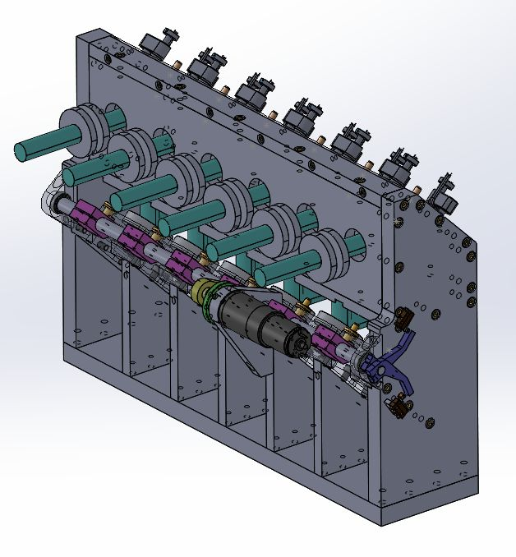
Figure 1: 3D view of the SFO

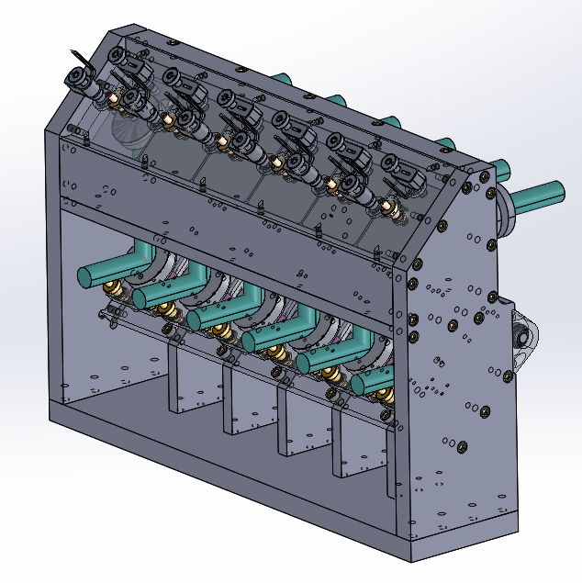
Figure 2: 3D view of the SFO

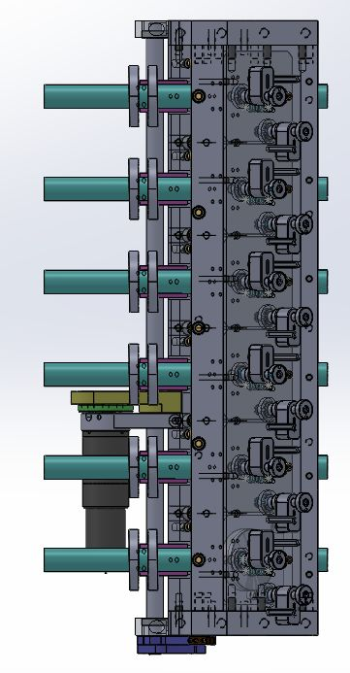
Figure 3: 3D view of the SFO
The periscope is made of 2 mirrors (FOP & IMG) on each of the six beams. The 6 FOP mirrors are mounted on a switchable system, each FOP mirror being mounted independently on a static device permitting a perfectly repeatable position in SPICA mode. The 6 IMG mirrors are mounted on a Tip Tilt system equipped with motorized actuators (Newport pico-motor piezo actuators) for the conjugation of the CHARA and SPICA beams, in combination with the six PUP mirrors located in an image plane on the injection table. The stroke and resolution of the Newport pico-motor piezo actuators are 9.5mm and 30nm respectively. Besides the rotation center of the IMG Tip Tilt system is defined at the mirror center by construction. So, the settings of the IMG mirrors are well within the specifications: the resolution of the Tip Tilt system is 1μrad << specification of 10’’ (48μrad).
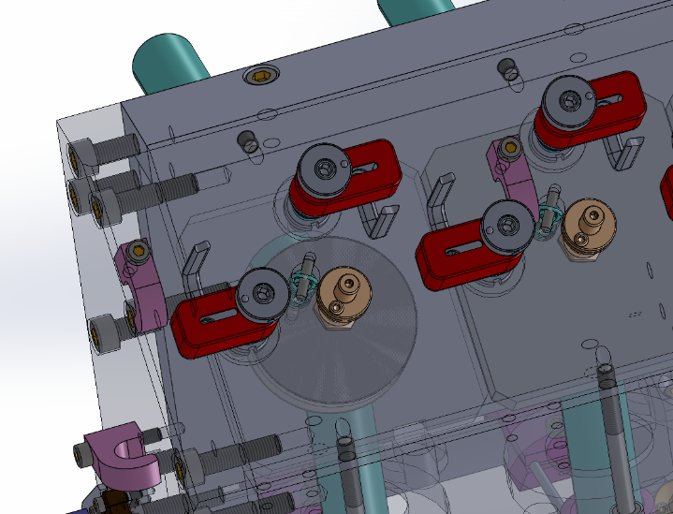
Figure 4: Zoom on the OMG Tip Tilt system
We plan to use the motor of the VEGA periscope for moving the 6 FOP mirrors simultaneously. We checked that the whole motor/gearbox (Faulhaber: MicroMotor 3242G024CR and gearbox 38/2S415:1) can drive the 6 FOP mirrors without any problem. Through an eccentric drive, the 6 FOP mirrors go from the DOWN position (beams sent to SPICA) to the UP position (CHARA reference source). 2 limit switches define these UP/DOWN positions.
Each FOP mirror rests on a support which is fixed on the motor axis. A spring maintains it on its support except for the UP position. In this position, the spring pulls the M1 mirror on kinematic points. This system (illustrated in Figure 5) guarantees a good repeatability. Based on our experience with the VEGA periscope, we expect a repeatability well within the specifications (the pupil is not translated more than 1mm, so 5% of its diameter and that its deviation is smaller than 10’’). We plan to check it as soon as the module will be ready.
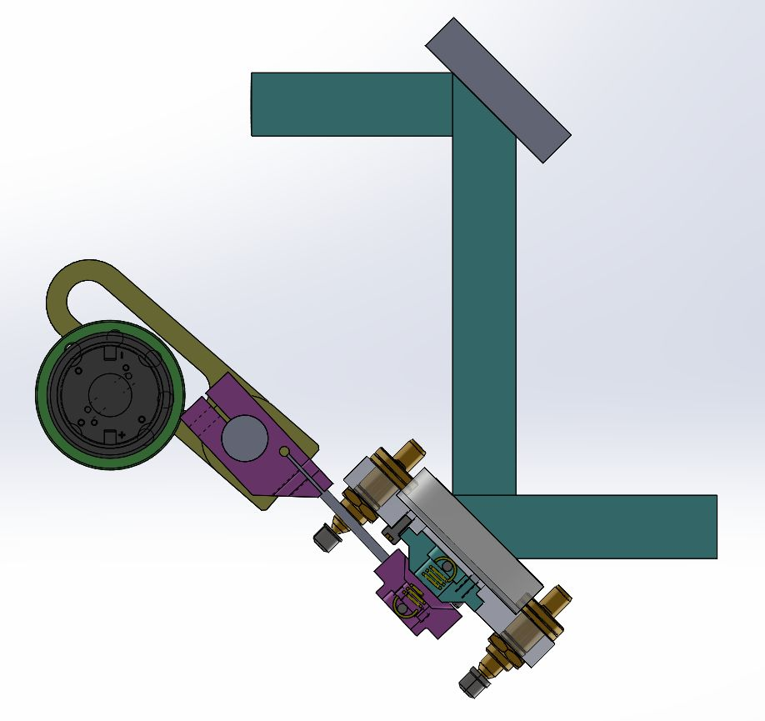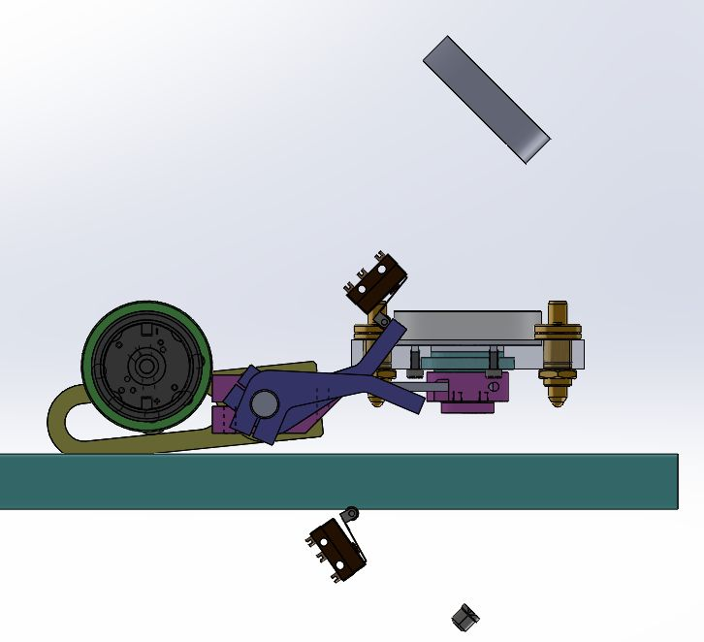
Figure 5: Zoom on the FOP switchable system: UP position (left) and DOWN position (right)

Custom Rotation Stage
In the SPICA injection Table, there are 17 motorized rotation stages (12 for ADC and 5 for PDC). Such commercial rotation stage costs at least 500€ without the controller. We decided to develop a custom “low cost” motorized rotation stage. A prototype of the system is presented in Figure 6.
It is composed of a small gear wheel fixed on a stepper motor which drives a big gear wheel thanks to a toothed belt. We selected a hybrid stepper motor from Lin Engineering (WO-3709V-03) with a step angle of 0.9°. The angular resolution of the system is therefore given by the ratio of the number of teeth between both gear wheels. Even if we decide to operate the stepper motor on full steps only, we can easily achieve the ADC and PDC specifications: 0.5° and 0.1° respectively (see SPICA-VIS-0004).
Figure 6: Custom rotation stage prototype

In terms of repeatability, we did some tests with the prototype. We obtained an angular repeatability of 0.02° (RMS).
The price of this custom rotation stage is around 100€.

Atmospheric Dispersion Compensator (ADC)
The mechanical design of the ADC is presented in Figure 7. Each ADC is composed of 2 custom rotation stages on which the prisms are glued. The 12 rotation stages are fixed on a first plate (upper part of Figure 7). This module is then attached to the SFO structure over the first optics of the CHARA visible table.
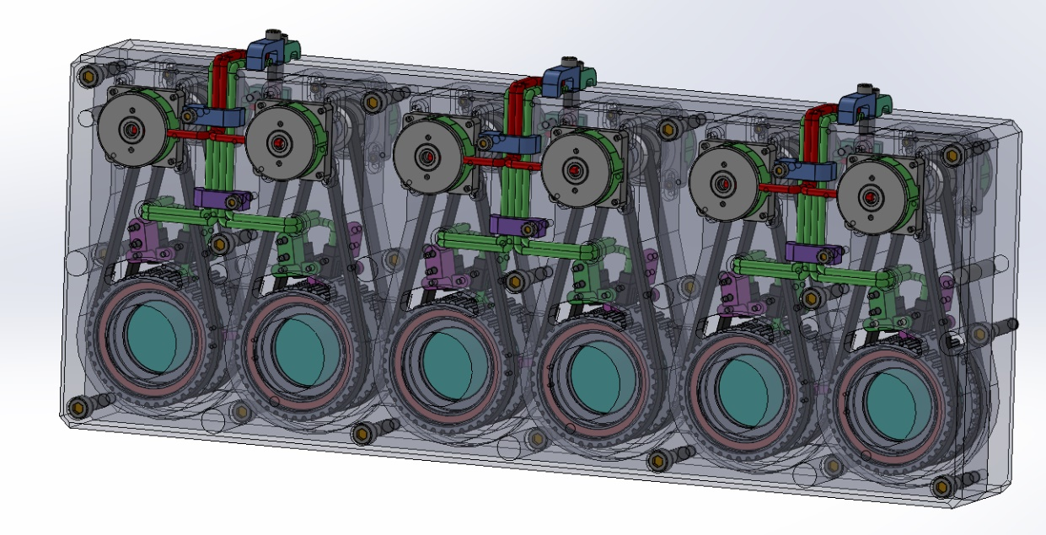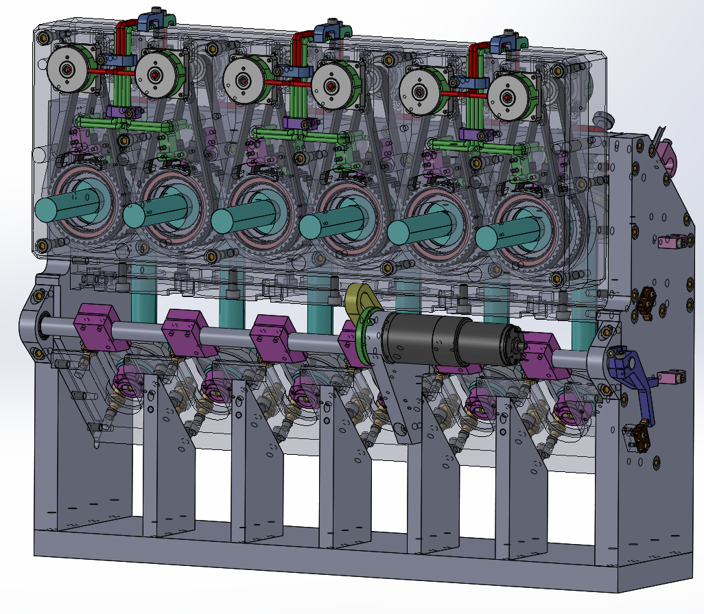
Figure 7: 3D view of ADC

2.4 INjection Module (INM)
The INM is a lens system made with an achromatic doublet and a plano-convex, from Thorlabs. We decided to use Thorlabs tubes to maintain the lenses at their adequate position. The fiber must be at the exact focus (+/- 10μm) of the plano-convex lens in order to maximize the coupling. We selected a high precision zoom housing (Thorlabs) which could be fixed to the tube. The FC/PC adapter is mounted on the movable part of the zoom housing. The system is presented in Figure 9. The centering of the fiber in the plane perpendicular to the tube is not adjustable. It is given by the Thorlabs tube system (the tolerance of the centering is not so tight). The high precision zoom housing provides 4.1mm of linear travel at 0.5mm per revolution without rotating the optical element mounted in it. This zoom housing provides also a locking system. We developed a testbench for measuring the coupling efficiency of this module. The testbench is presented in Figure 8. The light coming from a collimated source is divided into 2 parts thanks to a beam splitter. The first part is directly imaged on the detector, the second part is injected into the fiber. A motorized Tip Tilt system is placed just before the injection module in order to optimize the coupling.

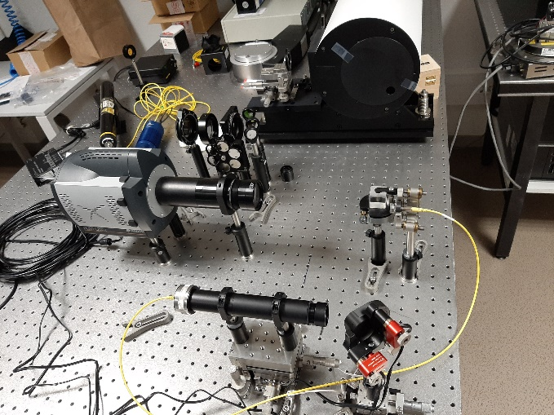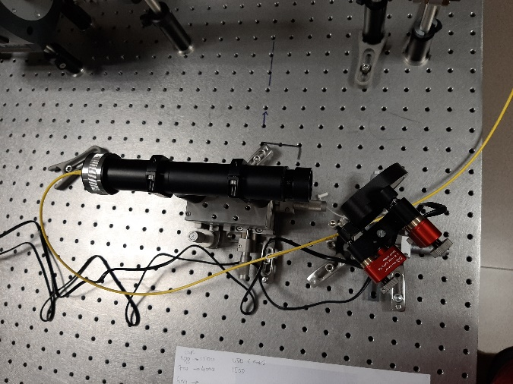
Figure 8: Injection Testbench (left) and zoom on the injection module (right)
With this prototype, we reached a coupling of 75% (corrected from the wave front aberrations, λ/10 rms at 633nm) instead of the theoretical 83%.
This prototype seems to be in the specification (coupling loss lower than 10% of the theoretical value) but we still need to check that the coupling is constant over the whole spectral band [650,850].

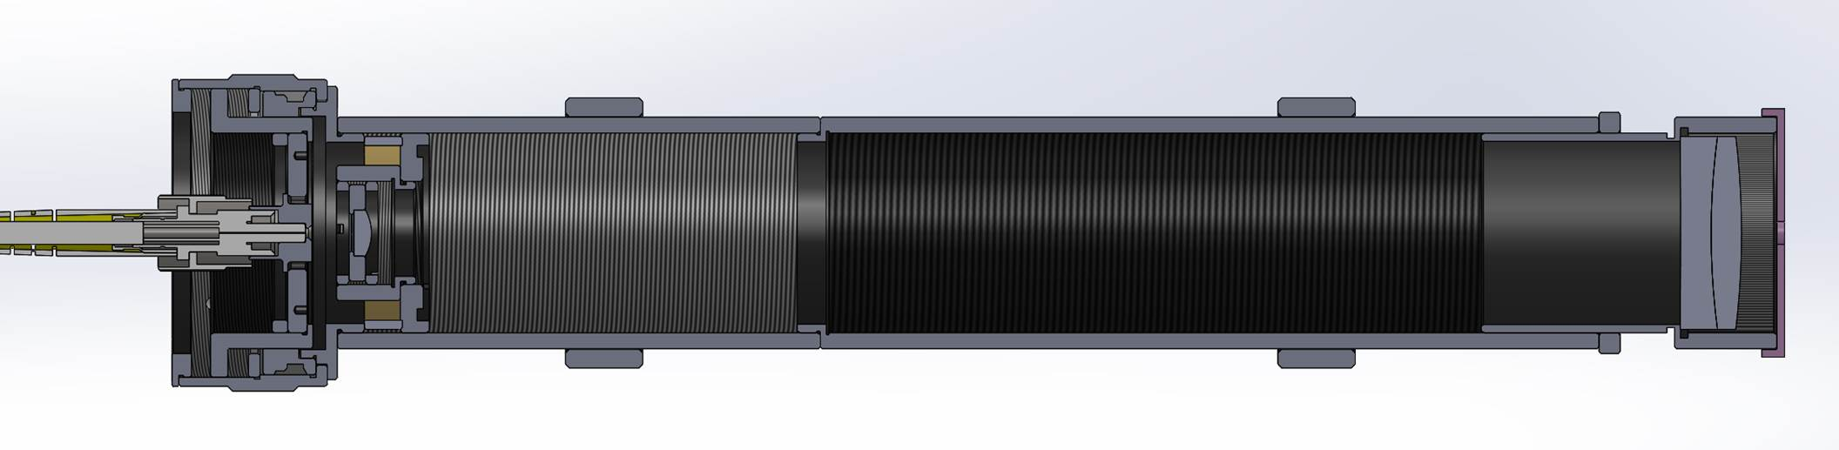
Figure 9: INjection Module Mechanical Design

Spectrograph
The mechanical design of the spectrograph will start at the end of the optical design. But we can already identify the complex modules in terms of mechanical design:
- The Dispersion System (DIS) contains several motorized axes: one rotation stage for selecting the dispersive elements, one rotation stage for selecting the central wavelength of the MEDIUM spectral resolution, one rotation stage for selecting the central wavelength of the HIGH spectral resolution and one linear stage for inserting the prism for the LOW spectral resolution. We keep also the option to re-use the mechanical system of the VEGA dispersion system. In this system, the same motor is sued for selecting the central wavelength of several dispersive optics.
- The Reception Module (RCM) holds the V Groove. We have already designed such support for FRIEND.
- The Fiber Back Illumination module (FBI) will be motorized in order to back-illuminate all fibers simultaneously.

STS-VIS
The STS-VIS module is a copy of the STS IR folding mirror module. It will be installed on the metrology table next to the STS IR folding mirror module. Its mechanical design is presented in Figure 11. The plate supporting the 6 beam-splitters is fixed on a linear translation stage (Newport). This linear stage could be moved thanks to a stepper motor (LE14S3150 from Lin Engineering). We used 2 limit switches in order to define the ON (light coming from the STS sent to SPICA-VIS) and OFF (light coming from the telescope sent to SPICA-VIS) positions. We decided to use dichroic beamsplitters from Thorlabs (DMLP900L). The wavelengths below 900nm will be reflected towards visible instrument and the wavelengths above 900nm will go towards STS_IR mirrors (see Figure 10). They are mounted on motorized Tip Tilt modules (8742-4-8821-LL from Newport).
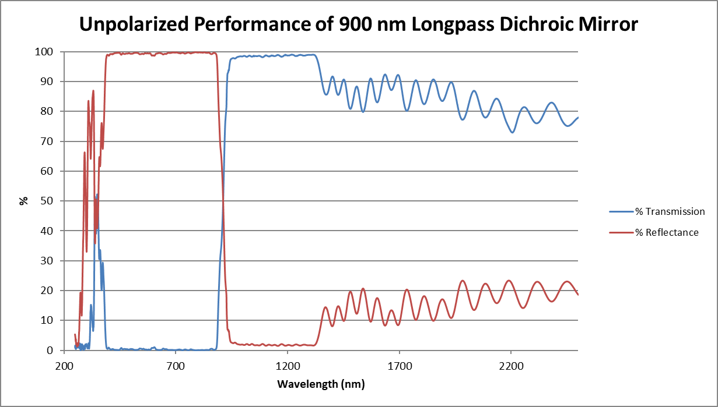
Figure 10: Dichroics BeamSplitters performance
In terms of control software, we think the control of the STS-VIS should be done in the existing STS server. STS-IR and STS-VIS should be moved simultaneously.

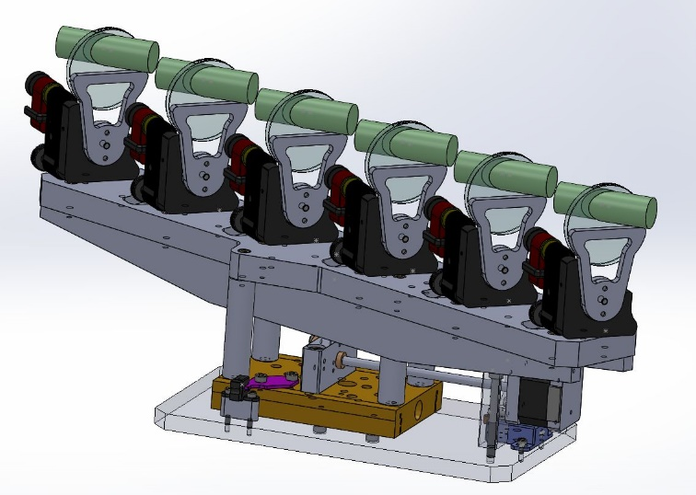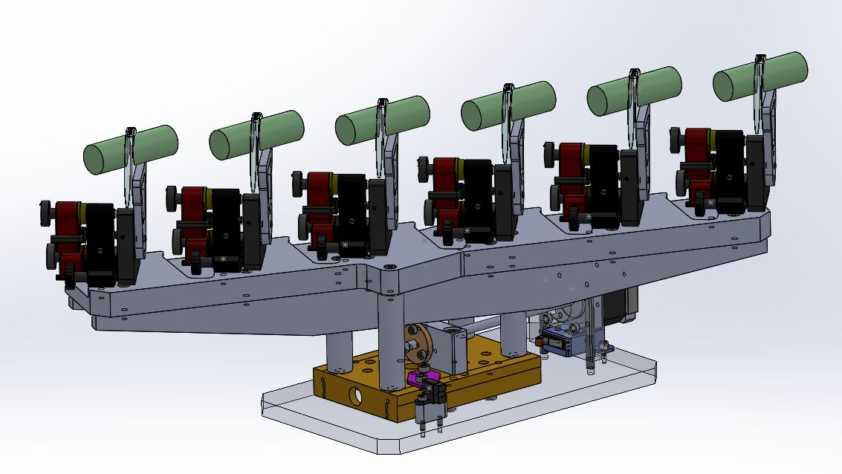
Figure 11: 3D view of STS-VIS

Visible LDC
The visible LDC will be installed on the metrology table just after the STS-VIS. Each module is made of 2 prisms. The first prism is mounted on manual Tip Tilt module and the second one is fixed on a motorized linear stage (see Figure 12). We selected a Newport linear stage (MFA-PPD), the same than we plan to use for the SPICA-VIS internal Delay Line. This linear stage could be operated with the controller SMC100PP.
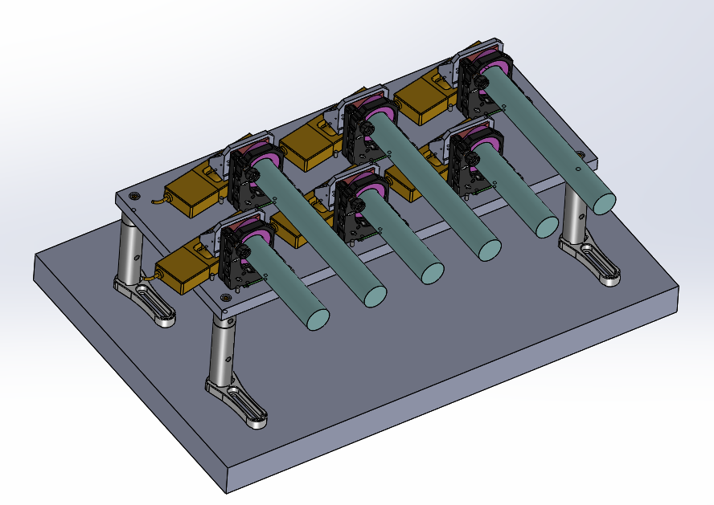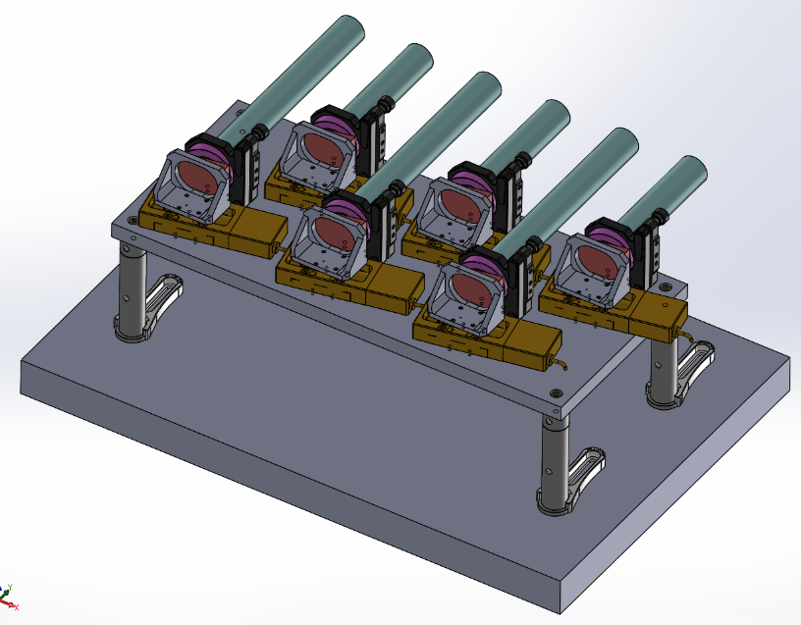
Figure 12: Visible LDC mechanical design

